Does Copy-Paste Augmentation Rescue the Rare Classes?
An Instance Copy-Paste Study on a Four-Class ADE20K Subset with a U-Net / EfficientNet-B3
Muhammad Waqas | 22079344
Github: https://github.com/waqas034/image_segmentation_assignment.git

1 Introduction and related work

Semantic segmentation assigns a label to each pixel of an image; on a small imbalanced dataset the rare classes are the entire challenge. This project tackles one targeted remedy directly, namely instance copy-paste augmentation (Ghiasi et al., 2021), which copies the objects instances and pastes them in new scenes to create rare-class training pixels. The task is four-class segmentation of a subset of ADE20K with only 350 images (Zhou et al., 2017) , person, car, book and airplane over a background , where airplane is only present in 5 training images.

The segmenter is based on U-Net (Ronneberger et al., 2015) with skip connections to retain the fine spatial detail the small objects require, and uses an EfficientNet-B3 (Tan and Le, 2019) pre-trained on ImageNet as the encoder. To evaluate the impact of copy-paste, the same network is trained twice with the same parameters, only with book and airplane instances being pasted into training scenes, and both are compared to a COCO-pre-trained DeepLabV3-ResNet50 (Chen et al., 2017) as an off-the-shelf reference. The question remains simple - do additional copies of the two rarest classes improve their IoU without impacting the common classes? Each score is the per-class IoU and Dice on the 350 validation images, with the winner being ranked by foreground mean IoU across the four classes, excluding the background class.

2 Data and exploratory analysis
The exploratory analysis quantifies the imbalance which motivates the study. In the background, there are 233 training images with 'person', 148 with 'car', 51 with 'book', and just 5 with 'airplane' (Figure 1), and background dominates the pixel budget. The numbers of instances are even more drastic: 137 rare instances, 127 book and only 10 airplane were collected from these masks by copy-paste bank, which is also the whole airplane material in the training set.
The co-occurrence analysis reveals that person and car frequently co-occur with street scenes, whereas airplane occurs almost only in isolation, a scenario which the model is not used to. The masks are first decoded from their COCO run-length format, with large objects being painted first; this means that small book and airplane regions persist in the masks. Since the whole idea is to add these rare-class pixels, this fifth exploratory view (Figure 2) displays a copy-paste-augmented scene (book and airplane instances pasted into an unrelated image and the corresponding copy-paste-augmented edits to the label map), so that the augmentation can be examined before it is trusted during training.
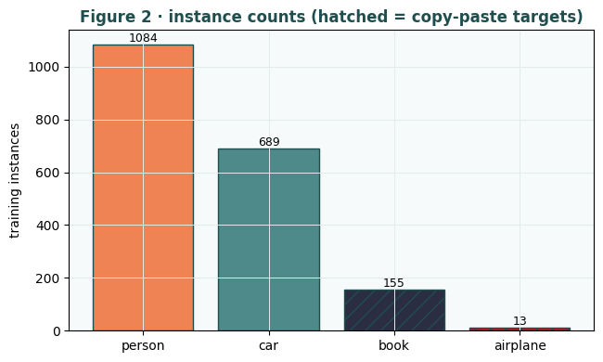
Figure 1. Training instance counts per class (hatched = copy-paste targets, book and airplane). Source: author.
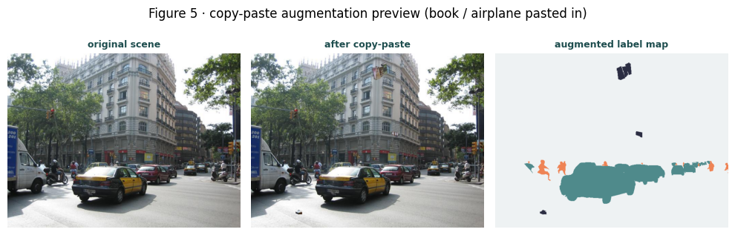
Figure 2. Copy-paste preview: original scene, after pasting book/airplane, and the augmented label map. Source: author.

3 Method
The design varies from one attribute. The rare-instance bank is created only once by simply cropping all the connected book or airplane regions from the training masks, and each image patch is stored with the binary mask. The copy-paste pipeline copies two random rare instances and scales them by a random scale and edits both the image and its label map during training, whereas the baseline pipeline is the same, but it does not copy and paste these instances.
Both are using the same U-Net / EfficientNet-B3 model (13.2M parameters), 384-pixel input image size, batch size 8, horizontal-flip and mild affine augmentation, Dice-plus-Focal loss, AdamW (3e-4), cosine schedule, up to 35 epochs with an early stopping criterion (patience 9), and a fixed seed (313), and any differences are due to "copy-paste". COCO-pre-trained DeepLabV3-Resnet50 comparator is fine-tuned at a gentler 1e-4. Evaluation is based on a confusion matrix assessing all the validation set, providing per class IoU and Dice and mean foreground IoU.

4 Results and discussion
The head to head is provided in Table 1. The most prominent effect is in the case of the airplane: the baseline never learns it (IoU 0.000), while copy-paste brings it to 0.288, a +0.288 jump, which is all due to pasting 10 airplane instances into much more scenes than the 5 that contain the airplane. That one change lifts the foreground mean IoU for the copy-paste model from 0.398 to 0.442 and pushes it past that of the COCO-pre-trained DeepLabV3-ResNet50 (0.427), making a from-scratch-decoder U-Net with copy-paste outperform a pre-trained model trained on a much larger segmentation dataset.
Not quite free everywhere; as the study's honest counter-finding concludes, book is down a bit from copy-paste (0.290 to 0.233, a drop of 0.057). There are two plausible explanations for it, firstly book had more than ten times as many instances, so had a lot less to gain, and secondly patching into scenes sometimes obscures book pixels or pushes the balance against book. The two U-Nets are not far apart on the common classes (person 0.627 versus 0.605, car 0.675 versus 0.641), which means that copy-paste is not hurting the head significantly while helping the tail. The per-class bars (Figure 3) allow for the airplane rescue and the small book regression to be seen side by side, and the confusion matrix (Figure 4) demonstrates that most errors in the test predictions (Figure 5) occur between background classes and not between classes: that is, that the model has segmented the images genuinely across all classes, not used a shortcut that works for the two classes.
The foreground mIoU (around 0.44) is a reasonable and honest metric for this simpler subset of 4 classes when compared to Zhou et al. (2017)'s mean IoU of 0.35 calculated over the entire 150 class ADE20K. The only thing is that the pasted Airplane is only as common as the Airplane instances that exist and with 10 of them, it's nowhere close to common classes. The obvious next steps are to collect more aircraft and to merge pasted instances more realistically (to minimize artefacts at the boundaries), and adjust the paste rate per class such that book is not driven to extinction, but airplane is rescued (Ghiasi et al., 2021).
Class | baseline | copy-paste | DeepLabV3 (pt)
person | 0.627 | 0.605 | 0.645
car | 0.675 | 0.641 | 0.677
book | 0.290 | 0.233 | 0.237
airplane | 0.000 | 0.288 | 0.149
mean IoU (fg) | 0.398 | 0.442 | 0.427
mean Dice (fg) | 0.507 | 0.590 | 0.558
Table 1. Per-class validation IoU, with foreground mean IoU and Dice (winning copy-paste column shaded). Source: author.
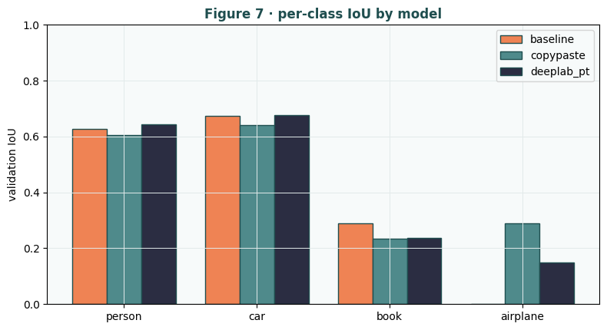
Figure 3. Per-class validation IoU by model; copy-paste lifts airplane from zero. Source: author.
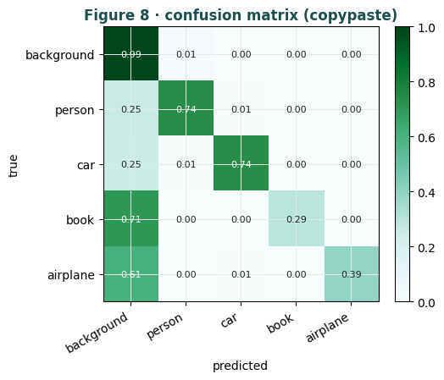
Figure 4. Confusion matrix of the best model; errors leak into background, not between classes. Source: author.
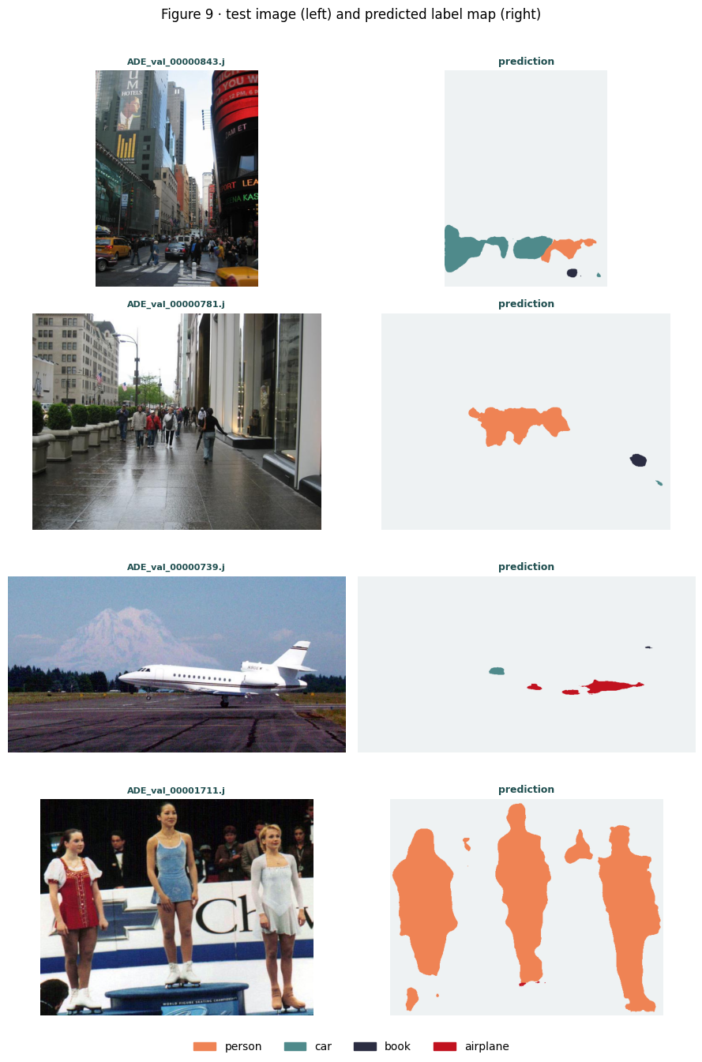
Figure 5. Predictions on unlabelled test images (left input, right predicted label map). Source: author.

References
Chen, L.-C., Papandreou, G., Schroff, F. and Adam, H. (2017) ‘Rethinking Atrous Convolution for Semantic Image Segmentation’, arXiv:1706.05587. doi: 10.48550/arXiv.1706.05587.
Ghiasi, G., Cui, Y., Srinivas, A., Qian, R., Lin, T.-Y., Cubuk, E. D., Le, Q. V. and Zoph, B. (2021) ‘Simple Copy-Paste is a Strong Data Augmentation Method for Instance Segmentation’, IEEE CVPR, pp. 2918–2928. doi: 10.1109/CVPR46437.2021.00294.
Ronneberger, O., Fischer, P. and Brox, T. (2015) ‘U-Net: Convolutional Networks for Biomedical Image Segmentation’, MICCAI, pp. 234–241. doi: 10.1007/978-3-319-24574-4_28.
Tan, M. and Le, Q. (2019) ‘EfficientNet: Rethinking Model Scaling for Convolutional Neural Networks’, ICML, pp. 6105–6114. Available at: https://proceedings.mlr.press/v97/tan19a.html.
Zhou, B., Zhao, H., Puig, X., Fidler, S., Barriuso, A. and Torralba, A. (2017) ‘Scene Parsing through ADE20K Dataset’, IEEE CVPR, pp. 5122–5130. doi: 10.1109/CVPR.2017.544.

Appendix: Code
# --- cell 1 ---
# smp gives the U-Net + EfficientNet-B3 encoder and the losses; leave Colab's torch/torchvision as-is.
!pip install -q segmentation-models-pytorch==0.5.0 albumentations pycocotools
print("libraries ready")
# --- cell 2 ---
import os, json, random, time, zipfile, ssl, glob
from collections import defaultdict
import numpy as np, pandas as pd
import cv2
import matplotlib.pyplot as plt
from matplotlib.colors import ListedColormap
from PIL import Image
import torch, torch.nn as nn, torch.nn.functional as F
from torch.utils.data import Dataset, DataLoader, WeightedRandomSampler
import segmentation_models_pytorch as smp
import albumentations as A
from albumentations.pytorch import ToTensorV2
from pycocotools import mask as coco_mask
ssl._create_default_https_context = ssl._create_unverified_context
import warnings; warnings.filterwarnings("ignore")
DEVICE = torch.device("cuda" if torch.cuda.is_available() else "cpu")
print("torch", torch.__version__, "| smp", smp.__version__, "| device", DEVICE)
if DEVICE.type != "cuda": print("Enable a GPU runtime before training.")
# --- cell 3 ---
# configuration held in one dict, printed once so the whole run is reproducible from this cell
CFG = dict(zip_path="/content/RMDS_segmentation_dataset_ADE20K_350.zip", data_dir="/content/ade_waqas",
out_dir="/content/waqas_out", img=384, batch=8, epochs=35, lr=3e-4, lr_pt=1e-4, wd=1e-4,
patience=9, seed=313, workers=2, amp=True, paste_prob=0.7, paste_k=2)
os.makedirs(CFG["out_dir"], exist_ok=True)
def seed_all(s=CFG["seed"]):
random.seed(s); np.random.seed(s); torch.manual_seed(s); torch.cuda.manual_seed_all(s)
torch.backends.cudnn.deterministic = True; torch.backends.cudnn.benchmark = False
seed_all()
GEN = torch.Generator().manual_seed(CFG["seed"])
RNG = random.Random(CFG["seed"])
CATID = {4: 1, 9: 2, 40: 3, 59: 4} # VERIFIED from instances_train.json
CLASSES = ["background", "person", "car", "book", "airplane"]; NC = len(CLASSES)
FG = list(range(1, NC)); RARE = [3, 4] # book, airplane are the copy-paste targets
# teal / orange palette (distinct)
HEX = ["#eef2f3", "#ef8354", "#4f8a8b", "#2b2d42", "#c1121f"]
PAL = np.array([[int(h[i:i+2], 16) for i in (1, 3, 5)] for h in HEX], np.uint8)
CMAP = ListedColormap(PAL / 255.0)
plt.rcParams.update({"figure.facecolor": "white", "axes.facecolor": "#f7fafa", "axes.grid": True,
"grid.color": "#e2eaea", "grid.linewidth": 0.7, "axes.titleweight": "bold", "axes.titlecolor": "#1f4e4f"})
print("config ready | rare-class paste targets:", [CLASSES[c] for c in RARE])
# --- cell 4 ---
def find_root(base):
hits = glob.glob(os.path.join(base, "**", "instances_train.json"), recursive=True)
if not hits: raise FileNotFoundError("instances_train.json not found")
return os.path.dirname(hits[0])
if not glob.glob(os.path.join(CFG["data_dir"], "**", "instances_train.json"), recursive=True):
os.makedirs(CFG["data_dir"], exist_ok=True)
assert os.path.exists(CFG["zip_path"]), f"upload the dataset to {CFG['zip_path']}"
with zipfile.ZipFile(CFG["zip_path"]) as z: z.extractall(CFG["data_dir"])
ROOT = find_root(CFG["data_dir"]); print("data root:", ROOT)
def index_split(split):
meta = json.load(open(os.path.join(ROOT, f"instances_{split}.json")))
imgs = {im["id"]: im for im in meta["images"]}
anns = defaultdict(list)
for a in meta["annotations"]: anns[a["image_id"]].append(a)
return imgs, anns
def rasterise(im, anns):
lab = np.zeros((im["height"], im["width"]), np.uint8)
for a in sorted(anns, key=lambda x: -x["area"]):
c = CATID.get(a["category_id"])
if c is not None: lab[coco_mask.decode(a["segmentation"]).astype(bool)] = c
return lab
def cache(split):
imgs, anns = index_split(split); mdir = os.path.join(CFG["out_dir"], "masks", split)
os.makedirs(mdir, exist_ok=True); recs = []
for iid, im in imgs.items():
mp = os.path.join(mdir, os.path.splitext(im["file_name"])[0] + ".png")
if not os.path.exists(mp): Image.fromarray(rasterise(im, anns[iid]), "L").save(mp)
recs.append(dict(img=os.path.join(ROOT, split, im["file_name"]), msk=mp, file=im["file_name"]))
return recs
def list_test():
dd = os.path.join(ROOT, "test")
return [dict(img=os.path.join(dd, f), file=f) for f in sorted(os.listdir(dd)) if f.lower().endswith(".jpg")]
t0 = time.time()
DATA = {"train": cache("train"), "val": cache("val"), "test": list_test()}
print(f"cached in {time.time()-t0:.1f}s | train {len(DATA['train'])} val {len(DATA['val'])} test {len(DATA['test'])} (unlabelled)")
# --- cell 5 ---
# integrity: images and pixels per class
def stats(split):
px = np.zeros(NC, np.int64); im = np.zeros(NC, int)
for r in DATA[split]:
b = np.bincount(np.asarray(Image.open(r["msk"])).ravel(), minlength=NC); px += b; im += (b > 0)
return px, im
PIX, IMG = stats("train"); _, IMGV = stats("val")
print("train images/class:", {CLASSES[c]: int(IMG[c]) for c in range(NC)})
print("val images/class:", {CLASSES[c]: int(IMGV[c]) for c in range(NC)})
# --- cell 6 ---
rows = []
for split in ("train", "val"):
imgs, anns = index_split(split)
for iid, im in imgs.items():
for a in anns[iid]:
c = CATID.get(a["category_id"])
if c: rows.append(dict(split=split, cls=CLASSES[c], areaf=a["area"] / (im["width"] * im["height"])))
OBJ = pd.DataFrame(rows); print("object instances:", len(OBJ))
# --- cell 7 ---
# Figure 1 - training pixel share per class (log scale so rare classes are visible)
share = PIX / PIX.sum()
fig, ax = plt.subplots(figsize=(6.8, 4))
b = ax.bar(CLASSES, np.maximum(share, 1e-5), color=[PAL[c] / 255 for c in range(NC)], edgecolor="#1f4e4f")
ax.set_yscale("log"); ax.set_ylabel("pixel share (log)")
for r, c in zip(b, range(NC)): ax.text(r.get_x()+r.get_width()/2, r.get_height(), f"{100*share[c]:.2f}%", ha="center", va="bottom", fontsize=8)
ax.set_title("Figure 1 · training pixel share per class"); plt.tight_layout(); plt.show()
# --- cell 8 ---
# Figure 2 - instance counts, highlighting the two rare paste-target classes
counts = OBJ[OBJ.split=="train"]["cls"].value_counts().reindex(CLASSES[1:]).fillna(0).astype(int)
fig, ax = plt.subplots(figsize=(6.6, 4))
bars = ax.bar(counts.index, counts.values, color=[PAL[c]/255 for c in FG], edgecolor="#1f4e4f")
for i, c in enumerate(FG):
if c in RARE: bars[i].set_hatch("//")
for r, v in zip(bars, counts.values): ax.text(r.get_x()+r.get_width()/2, v, str(v), ha="center", va="bottom", fontsize=9)
ax.set_ylabel("training instances"); ax.set_title("Figure 2 · instance counts (hatched = copy-paste targets)")
plt.tight_layout(); plt.show()
# --- cell 9 ---
# Figure 3 - class co-occurrence P(row also has column)
imgs, anns = index_split("train"); present = [{CATID[a["category_id"]] for a in anns[i] if a["category_id"] in CATID} for i in imgs]
M = np.zeros((len(FG), len(FG)))
for i, a in enumerate(FG):
ha = [p for p in present if a in p]
for j, b in enumerate(FG): M[i, j] = np.mean([b in p for p in ha]) if ha else 0
fig, ax = plt.subplots(figsize=(5.2, 4.4)); im = ax.imshow(M, cmap="BuGn", vmin=0, vmax=1)
ax.set_xticks(range(len(FG))); ax.set_xticklabels(CLASSES[1:], rotation=30, ha="right"); ax.set_yticks(range(len(FG))); ax.set_yticklabels(CLASSES[1:])
for i in range(len(FG)):
for j in range(len(FG)): ax.text(j, i, f"{M[i,j]:.2f}", ha="center", va="center", color="white" if M[i,j]>.5 else "#222", fontsize=8)
ax.set_title("Figure 3 · P(row also contains column)"); fig.colorbar(im, fraction=.046); plt.tight_layout(); plt.show()
# --- cell 10 ---
# Figure 4 - sample images and colour-coded label maps (one per foreground class)
by = {c: [r for r in DATA["train"] if c in np.unique(np.asarray(Image.open(r["msk"])))] for c in FG}
picks = [RNG.choice(by[c]) for c in [4, 3, 2, 1] if by[c]]
fig, ax = plt.subplots(len(picks), 2, figsize=(6.2, 2.9*len(picks)))
for r, rec in enumerate(picks):
ax[r,0].imshow(Image.open(rec["img"]).convert("RGB")); ax[r,0].set_title(rec["file"][:18], fontsize=8)
ax[r,1].imshow(PAL[np.asarray(Image.open(rec["msk"]))]); ax[r,1].set_title("label map", fontsize=8)
for a in ax[r]: a.axis("off")
fig.suptitle("Figure 4 · images and label maps"); plt.tight_layout(); plt.show()
# --- cell 11 ---
# build the rare-instance bank from connected components of book/airplane in the TRAIN masks
def build_bank():
bank = []
for r in DATA["train"]:
lab = np.asarray(Image.open(r["msk"])); img = None
for c in RARE:
if not (lab == c).any(): continue
n, comp = cv2.connectedComponents((lab == c).astype(np.uint8))
for k in range(1, n):
ys, xs = np.where(comp == k)
if len(ys) < 64: continue # skip tiny specks
if img is None: img = np.array(Image.open(r["img"]).convert("RGB"))
y0, y1, x0, x1 = ys.min(), ys.max()+1, xs.min(), xs.max()+1
bank.append((img[y0:y1, x0:x1].copy(), (comp[y0:y1, x0:x1] == k), c))
return bank
RARE_BANK = build_bank()
print("rare-instance bank size:", len(RARE_BANK),
"| book:", sum(1 for _,_,c in RARE_BANK if c==3), "| airplane:", sum(1 for _,_,c in RARE_BANK if c==4))
def copy_paste(img, lab, k):
out_i, out_l = img.copy(), lab.copy(); H, W = lab.shape
for _ in range(k):
crop, m, c = RARE_BANK[RNG.randrange(len(RARE_BANK))]
s = RNG.uniform(0.7, 1.3)
ch, cw = max(8, int(crop.shape[0]*s)), max(8, int(crop.shape[1]*s))
if ch >= H or cw >= W: continue
ci = cv2.resize(crop, (cw, ch), interpolation=cv2.INTER_LINEAR)
cm = cv2.resize(m.astype(np.uint8), (cw, ch), interpolation=cv2.INTER_NEAREST).astype(bool)
y, x = RNG.randint(0, H-ch), RNG.randint(0, W-cw)
out_i[y:y+ch, x:x+cw][cm] = ci[cm]; out_l[y:y+ch, x:x+cw][cm] = c
return out_i, out_l
# --- cell 12 ---
# Figure 5 - copy-paste PREVIEW: a base scene before and after pasting rare instances
base = RNG.choice([r for r in DATA["train"] if 2 in np.unique(np.asarray(Image.open(r["msk"])))])
bi = np.array(Image.open(base["img"]).convert("RGB")); bl = np.asarray(Image.open(base["msk"])).copy()
seed_all(); pi, pl = copy_paste(bi, bl, 3)
fig, ax = plt.subplots(1, 3, figsize=(10, 3.4))
ax[0].imshow(bi); ax[0].set_title("original scene", fontsize=9)
ax[1].imshow(pi); ax[1].set_title("after copy-paste", fontsize=9)
ax[2].imshow(PAL[pl]); ax[2].set_title("augmented label map", fontsize=9)
for a in ax: a.axis("off")
fig.suptitle("Figure 5 · copy-paste augmentation preview (book / airplane pasted in)"); plt.tight_layout(); plt.show()
# --- cell 13 ---
IMEAN, ISTD = (0.485,0.456,0.406), (0.229,0.224,0.225)
def aug_train(s): return A.Compose([A.Resize(s,s), A.HorizontalFlip(p=0.5),
A.ShiftScaleRotate(0.06,0.1,15,border_mode=0,p=0.4), A.RandomBrightnessContrast(0.2,0.2,p=0.5),
A.Normalize(IMEAN,ISTD), ToTensorV2()])
def aug_eval(s): return A.Compose([A.Resize(s,s), A.Normalize(IMEAN,ISTD), ToTensorV2()])
class SegSet(Dataset):
"""copy_paste=True applies the rare-instance paste BEFORE resize/normalise; otherwise identical."""
def __init__(self, recs, tf, copy_paste_on=False):
self.r, self.tf, self.cp = recs, tf, copy_paste_on
def __len__(self): return len(self.r)
def __getitem__(self, i):
r = self.r[i]
img = np.array(Image.open(r["img"]).convert("RGB")); msk = np.asarray(Image.open(r["msk"]))
if self.cp and RARE_BANK and RNG.random() < CFG["paste_prob"]:
img, msk = copy_paste(img, msk, CFG["paste_k"])
o = self.tf(image=img, mask=np.ascontiguousarray(msk)); return o["image"], o["mask"].long(), r["file"]
def worker_seed(w): np.random.seed(CFG["seed"]+w); random.seed(CFG["seed"]+w)
def make_loader(copy_paste_on):
return DataLoader(SegSet(DATA["train"], aug_train(CFG["img"]), copy_paste_on), batch_size=CFG["batch"],
shuffle=True, num_workers=CFG["workers"], pin_memory=True, worker_init_fn=worker_seed, drop_last=True)
val_dl = DataLoader(SegSet(DATA["val"], aug_eval(CFG["img"])), batch_size=CFG["batch"], shuffle=False,
num_workers=CFG["workers"], pin_memory=True, worker_init_fn=worker_seed)
xb, yb, _ = next(iter(make_loader(True))); print("batch", tuple(xb.shape), "| labels", torch.unique(yb).tolist())
# --- cell 14 ---
class DiceFocal(nn.Module):
def __init__(self):
super().__init__(); self.dice = smp.losses.DiceLoss(mode="multiclass")
self.focal = smp.losses.FocalLoss(mode="multiclass", gamma=2.0)
def forward(self, logits, y): return self.dice(logits, y) + self.focal(logits, y)
class Meter:
def __init__(self, k=NC): self.k=k; self.cm=np.zeros((k,k), np.int64)
def add(self, logits, y):
p=logits.argmax(1).cpu().numpy().ravel(); t=y.cpu().numpy().ravel()
self.cm += np.bincount(t*self.k+p, minlength=self.k**2).reshape(self.k,self.k)
def scores(self):
cm=self.cm.astype(float); tp=np.diag(cm); fp=cm.sum(0)-tp; fn=cm.sum(1)-tp
iou=tp/np.maximum(tp+fp+fn,1e-9); dice=2*tp/np.maximum(2*tp+fp+fn,1e-9)
seen=[c for c in FG if cm[c].sum()>0]
return dict(iou=iou, dice=dice, cm=cm, miou=float(np.mean([iou[c] for c in seen])) if seen else 0.0,
mdice=float(np.mean([dice[c] for c in seen])) if seen else 0.0)
_t=torch.randint(0,NC,(2,16,16)); _m=Meter(); _m.add(F.one_hot(_t,NC).permute(0,3,1,2).float(),_t)
print("perfect-prediction fg mIoU:", round(_m.scores()["miou"],3))
# --- cell 15 ---
from torchvision.models.segmentation import deeplabv3_resnet50, DeepLabV3_ResNet50_Weights
class PretrainedDeepLab(nn.Module):
def __init__(self, n):
super().__init__(); net = deeplabv3_resnet50(weights=DeepLabV3_ResNet50_Weights.DEFAULT)
net.classifier[-1] = nn.Conv2d(256, n, 1); net.aux_classifier = None; self.net = net
def forward(self, x): return self.net(x)["out"]
def build(key):
if key in ("baseline", "copypaste"):
return smp.Unet(encoder_name="timm-efficientnet-b3", encoder_weights="imagenet", in_channels=3, classes=NC)
if key == "deeplab_pt": return PretrainedDeepLab(NC)
raise ValueError(key)
SPEC = {"baseline": dict(lr=CFG["lr"], cp=False), "copypaste": dict(lr=CFG["lr"], cp=True), "deeplab_pt": dict(lr=CFG["lr_pt"], cp=False)}
for k in SPEC:
m=build(k); print(f"{k:10s} {sum(p.numel() for p in m.parameters())/1e6:5.1f}M params"); del m
# --- cell 16 ---
@torch.inference_mode()
def evaluate(model):
model.eval(); mt=Meter()
for x,y,_ in val_dl:
with torch.autocast("cuda", enabled=CFG["amp"]): logits=model(x.to(DEVICE))
mt.add(logits.float(), y.to(DEVICE))
return mt.scores()
def fit(key):
seed_all(); GEN.manual_seed(CFG["seed"])
model=build(key).to(DEVICE); crit=DiceFocal().to(DEVICE)
loader=make_loader(SPEC[key]["cp"])
opt=torch.optim.AdamW(model.parameters(), lr=SPEC[key]["lr"], weight_decay=CFG["wd"])
sch=torch.optim.lr_scheduler.CosineAnnealingLR(opt, T_max=CFG["epochs"])
scaler=torch.amp.GradScaler("cuda", enabled=CFG["amp"])
best={"miou":-1}; ckpt=os.path.join(CFG["out_dir"], f"{key}.pt"); hist=[]; wait=0
for ep in range(1, CFG["epochs"]+1):
model.train(); run=0.0
for x,y,_ in loader:
x,y=x.to(DEVICE),y.to(DEVICE); opt.zero_grad(set_to_none=True)
with torch.autocast("cuda", enabled=CFG["amp"]): loss=crit(model(x), y)
scaler.scale(loss).backward(); scaler.step(opt); scaler.update(); run+=loss.item()*x.size(0)
sch.step(); s=evaluate(model); s["epoch"]=ep; s["loss"]=run/len(loader.dataset); hist.append(s)
if s["miou"]>best["miou"]: best=s; torch.save(model.state_dict(), ckpt); wait=0
else: wait+=1
print(f"[{key}] ep{ep:02d} loss {s['loss']:.3f} | val mIoU {s['miou']:.3f} (best {best['miou']:.3f}) | "
+" ".join(f"{CLASSES[c][:4]} {s['iou'][c]:.2f}" for c in FG))
if wait>=CFG["patience"]: print(f"[{key}] early stop"); break
return dict(key=key, best=best, ckpt=ckpt, hist=pd.DataFrame([{k:h[k] for k in ("epoch","loss","miou","mdice")} for h in hist]))
# --- cell 17 ---
RESULTS=[fit(k) for k in ("baseline","copypaste","deeplab_pt")]
board=pd.DataFrame([{"model":r["key"], "val_mIoU":r["best"]["miou"], "val_mDice":r["best"]["mdice"],
**{f"IoU_{CLASSES[c]}":r["best"]["iou"][c] for c in FG}} for r in RESULTS]).sort_values("val_mIoU", ascending=False).reset_index(drop=True)
board.to_csv(os.path.join(CFG["out_dir"],"leaderboard.csv"), index=False)
print("\nLeaderboard (validation):"); print(board.round(3).to_string(index=False))
if len(RESULTS)>=2:
base=next(r for r in RESULTS if r["key"]=="baseline"); cp=next(r for r in RESULTS if r["key"]=="copypaste")
print("\ncopy-paste minus baseline, per rare class:",
{CLASSES[c]: round(cp["best"]["iou"][c]-base["best"]["iou"][c],3) for c in RARE})
# --- cell 18 ---
# rubric (e) - per-class Dice for every model, reusing the same stored best-epoch score dicts as the IoU leaderboard
dice_board=pd.DataFrame([{"model":r["key"], "val_mDice":r["best"]["mdice"],
**{f"Dice_{CLASSES[c]}":r["best"]["dice"][c] for c in range(NC)}} for r in RESULTS]).sort_values("val_mDice", ascending=False).reset_index(drop=True)
dice_board.to_csv(os.path.join(CFG["out_dir"],"leaderboard_dice.csv"), index=False)
print("\nPer-class Dice (validation):"); print(dice_board.round(3).to_string(index=False))
# --- cell 19 ---
best=max(RESULTS, key=lambda r: r["best"]["miou"])
print("best:", best["key"], "| val mIoU", round(best["best"]["miou"],3))
model=build(best["key"]).to(DEVICE); model.load_state_dict(torch.load(best["ckpt"], map_location=DEVICE)); model.eval()
h=best["hist"]; fig,ax=plt.subplots(1,2,figsize=(11,3.6))
ax[0].plot(h["epoch"],h["loss"],color=PAL[1]/255); ax[0].set_title("Figure 6 · training loss"); ax[0].set_xlabel("epoch")
ax[1].plot(h["epoch"],h["miou"],color=PAL[2]/255,label="mIoU"); ax[1].plot(h["epoch"],h["mdice"],color=PAL[4]/255,label="mDice")
ax[1].set_title("Figure 6 · validation curves"); ax[1].set_xlabel("epoch"); ax[1].legend(); plt.tight_layout(); plt.show()
# --- cell 20 ---
# Figure 7 - per-class IoU across the three models
x=np.arange(len(FG)); w=0.26; fig,ax=plt.subplots(figsize=(8,4.4))
for k,r in enumerate(RESULTS):
ax.bar(x+(k-1)*w, [r["best"]["iou"][c] for c in FG], w, label=r["key"], color=PAL[k+1]/255, edgecolor="#1f4e4f")
ax.set_xticks(x); ax.set_xticklabels(CLASSES[1:]); ax.set_ylim(0,1); ax.set_ylabel("validation IoU")
ax.set_title("Figure 7 · per-class IoU by model"); ax.legend(); plt.tight_layout(); plt.show()
# --- cell 21 ---
# Figure 8 - confusion matrix of the best model (row-normalised)
cm=evaluate(model)["cm"]; cmn=cm/np.maximum(cm.sum(1,keepdims=True),1)
fig,ax=plt.subplots(figsize=(5.4,4.6)); im=ax.imshow(cmn,cmap="BuGn",vmin=0,vmax=1)
ax.set_xticks(range(NC)); ax.set_xticklabels(CLASSES,rotation=30,ha="right"); ax.set_yticks(range(NC)); ax.set_yticklabels(CLASSES)
for i in range(NC):
for j in range(NC): ax.text(j,i,f"{cmn[i,j]:.2f}",ha="center",va="center",color="white" if cmn[i,j]>.5 else "#222",fontsize=8)
ax.set_xlabel("predicted"); ax.set_ylabel("true"); ax.set_title(f"Figure 8 · confusion matrix ({best['key']})")
fig.colorbar(im,fraction=.046); plt.tight_layout(); plt.show()
print("VAL per-class IoU:", {CLASSES[c]: round(best["best"]["iou"][c],3) for c in FG})
# --- cell 22 ---
@torch.inference_mode()
def predict(model, image):
H,W=image.shape[:2]; t=aug_eval(CFG["img"])(image=image, mask=np.zeros((H,W),np.uint8))["image"][None].to(DEVICE)
lo=F.interpolate(model(t), size=(H,W), mode="bilinear", align_corners=False); return lo.argmax(1)[0].cpu().numpy().astype(np.uint8)
def test_panels(model, n=4):
ranked=[]
for r in DATA["test"]:
pr=predict(model, np.array(Image.open(r["img"]).convert("RGB"))); ranked.append((len(set(np.unique(pr))-{0}), int((pr>0).sum()), r))
ranked.sort(key=lambda t:(-t[0],-t[1])); picks=[t[2] for t in ranked[:n]]
fig,ax=plt.subplots(n,2,figsize=(9,3.4*n))
for i,r in enumerate(picks):
img=np.array(Image.open(r["img"]).convert("RGB")); pr=predict(model,img)
ax[i,0].imshow(img); ax[i,0].set_title(r["file"][:18],fontsize=8); ax[i,0].axis("off")
ax[i,1].imshow(PAL[pr]); ax[i,1].set_title("prediction",fontsize=9); ax[i,1].axis("off")
from matplotlib.patches import Patch
fig.legend(handles=[Patch(color=PAL[c]/255,label=CLASSES[c]) for c in FG], loc="lower center", ncol=4, frameon=False)
fig.suptitle("Figure 9 · test image (left) and predicted label map (right)"); plt.tight_layout(rect=[0,.03,1,.97]); plt.show()
test_panels(model, n=4)
print("Test is unlabelled -> qualitative only; metrics are on the validation split.")
# --- cell 23 ---
def infer(path, model=model):
img=np.array(Image.open(path).convert("RGB")); pr=predict(model,img)
fig,ax=plt.subplots(1,2,figsize=(9,4)); ax[0].imshow(img); ax[0].set_title("input"); ax[0].axis("off")
ax[1].imshow(PAL[pr]); ax[1].set_title("prediction"); ax[1].axis("off"); plt.tight_layout(); plt.show()
print("classes detected:", [CLASSES[c] for c in np.unique(pr) if c>0] or ["background only"])
_r=sorted(DATA["test"], key=lambda r:-int((predict(model,np.array(Image.open(r["img"]).convert("RGB")))>0).sum()))
infer(_r[0]["img"])
import shutil; shutil.copy(best["ckpt"], os.path.join(CFG["out_dir"],"best_model.pt"))
board.to_csv(os.path.join(CFG["out_dir"],"leaderboard.csv"), index=False)
print("saved best model + leaderboard to", CFG["out_dir"])

